MaxEnt supplementary results:

Average Omission and Predicted Area Curves

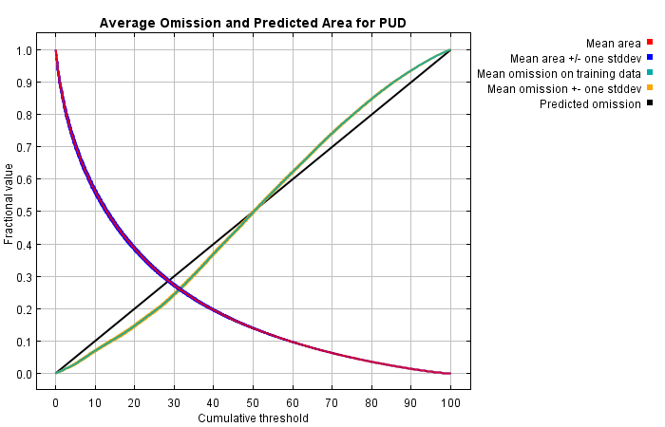

Figure S1: MaxEnt model gain averaged across 100 bootstrap replicates of 75:25 training and test data partitioning.

Receiver operating characteristic curve (ROC).

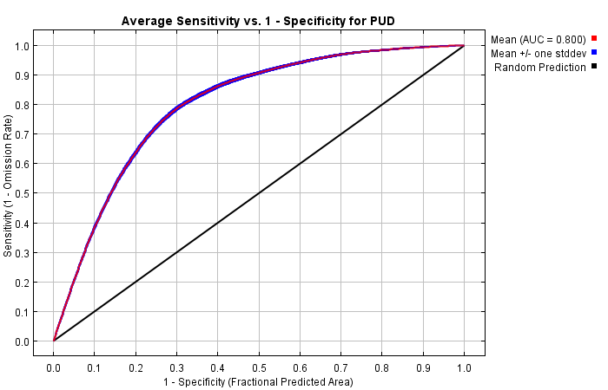

Figure S2: MaxEnt receiver operating curve plot averaged across 100 bootstrap replicates of 75:25 training and test data partitioning. AUC value of 0.8

Variable response plots: All curves show full model response (not single variable models).

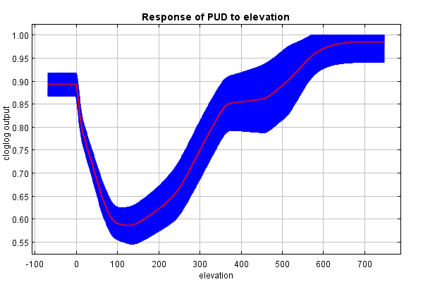

Figure 4: Response curve showing elevation variable.

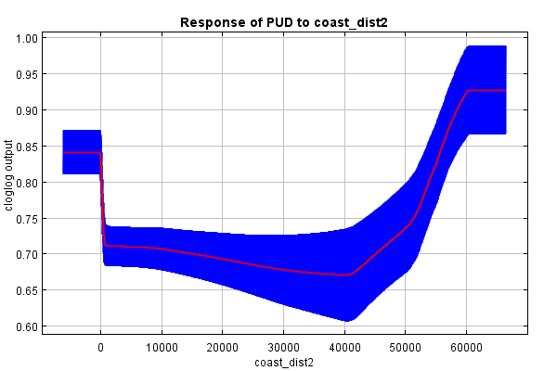

Figure 3: Response curve showing coastal distance variable.

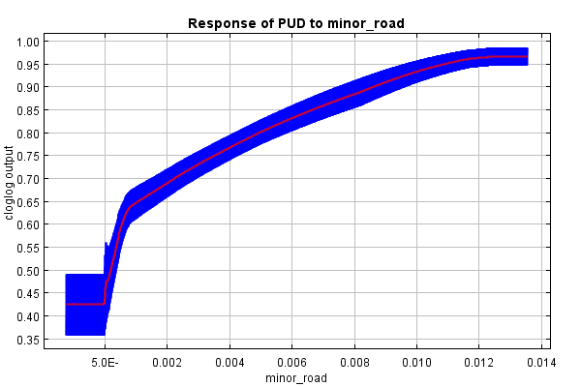

Figure 6: Response curve showing distance to path length (minor roads) variable.

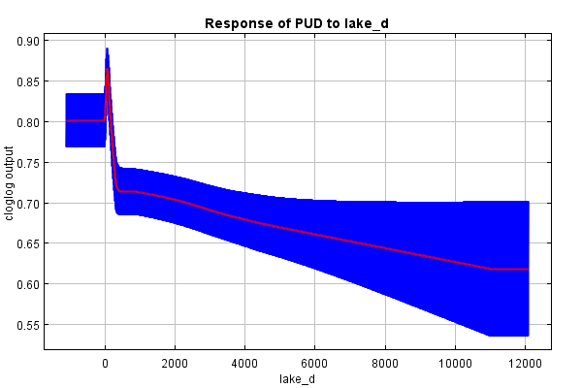

Figure 5: Response curve showing distance to lake variable.

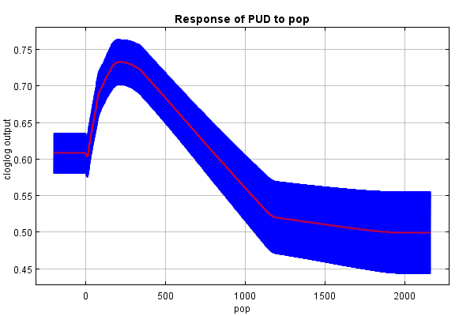

Figure 7: Response curve showing population variable.

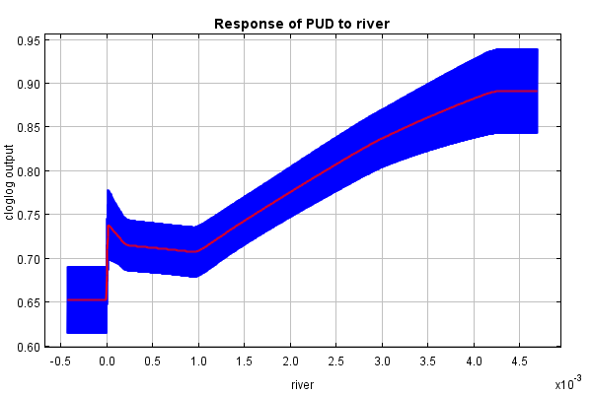

Figure 8: Response curve showing river length

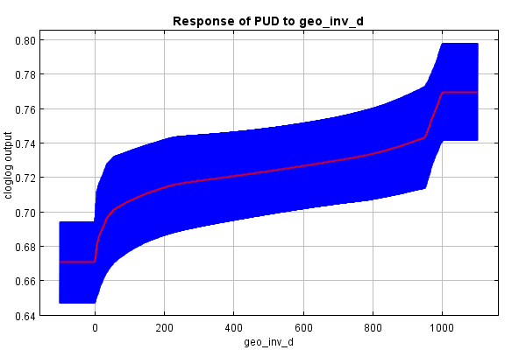

Figure 9: Response curve showing inverse distance to geological heritage (capped at 1000 m) variable.

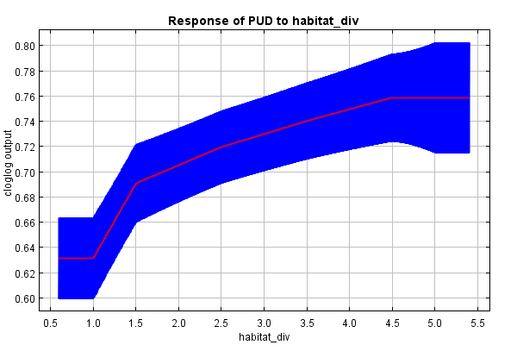

Figure 10: Response curve showing habitat diversity variable.

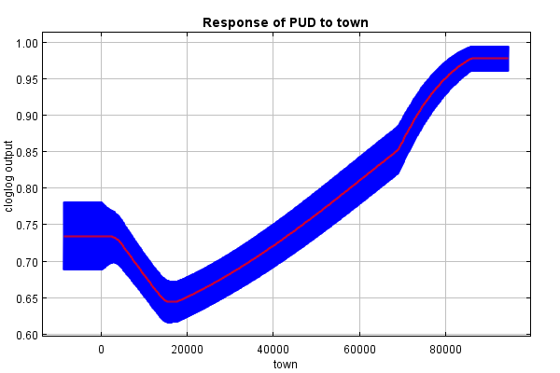

Figure 12: Response curve showing town distance variable.

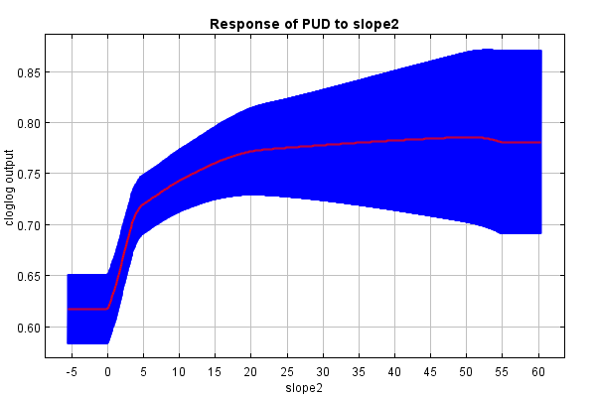

Figure 11: Response curve showing slope variable.

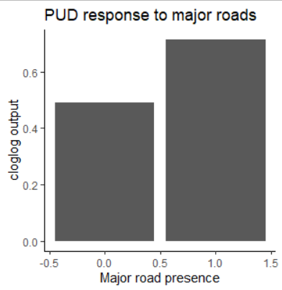

Figure 14: Response curve showing presence of major road variable.

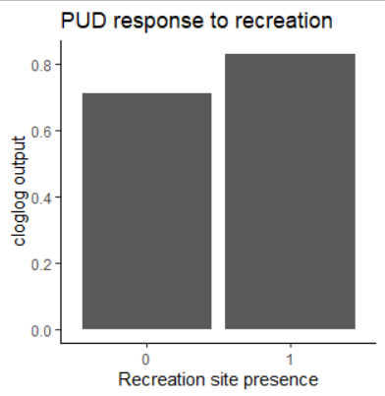

Figure 13: Response curve showing presence of recreational site variable.

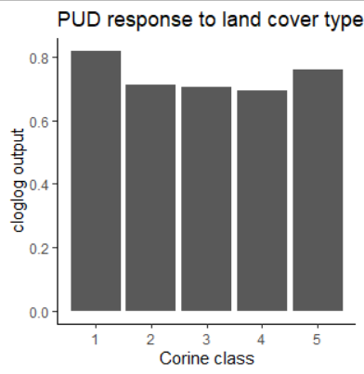

Figure 14: Response curve showing Corine land cover type variable. 1 = urban cover, 2 = agricultural, 3=forest and natural areas, 4=wetland, 5=water cover.