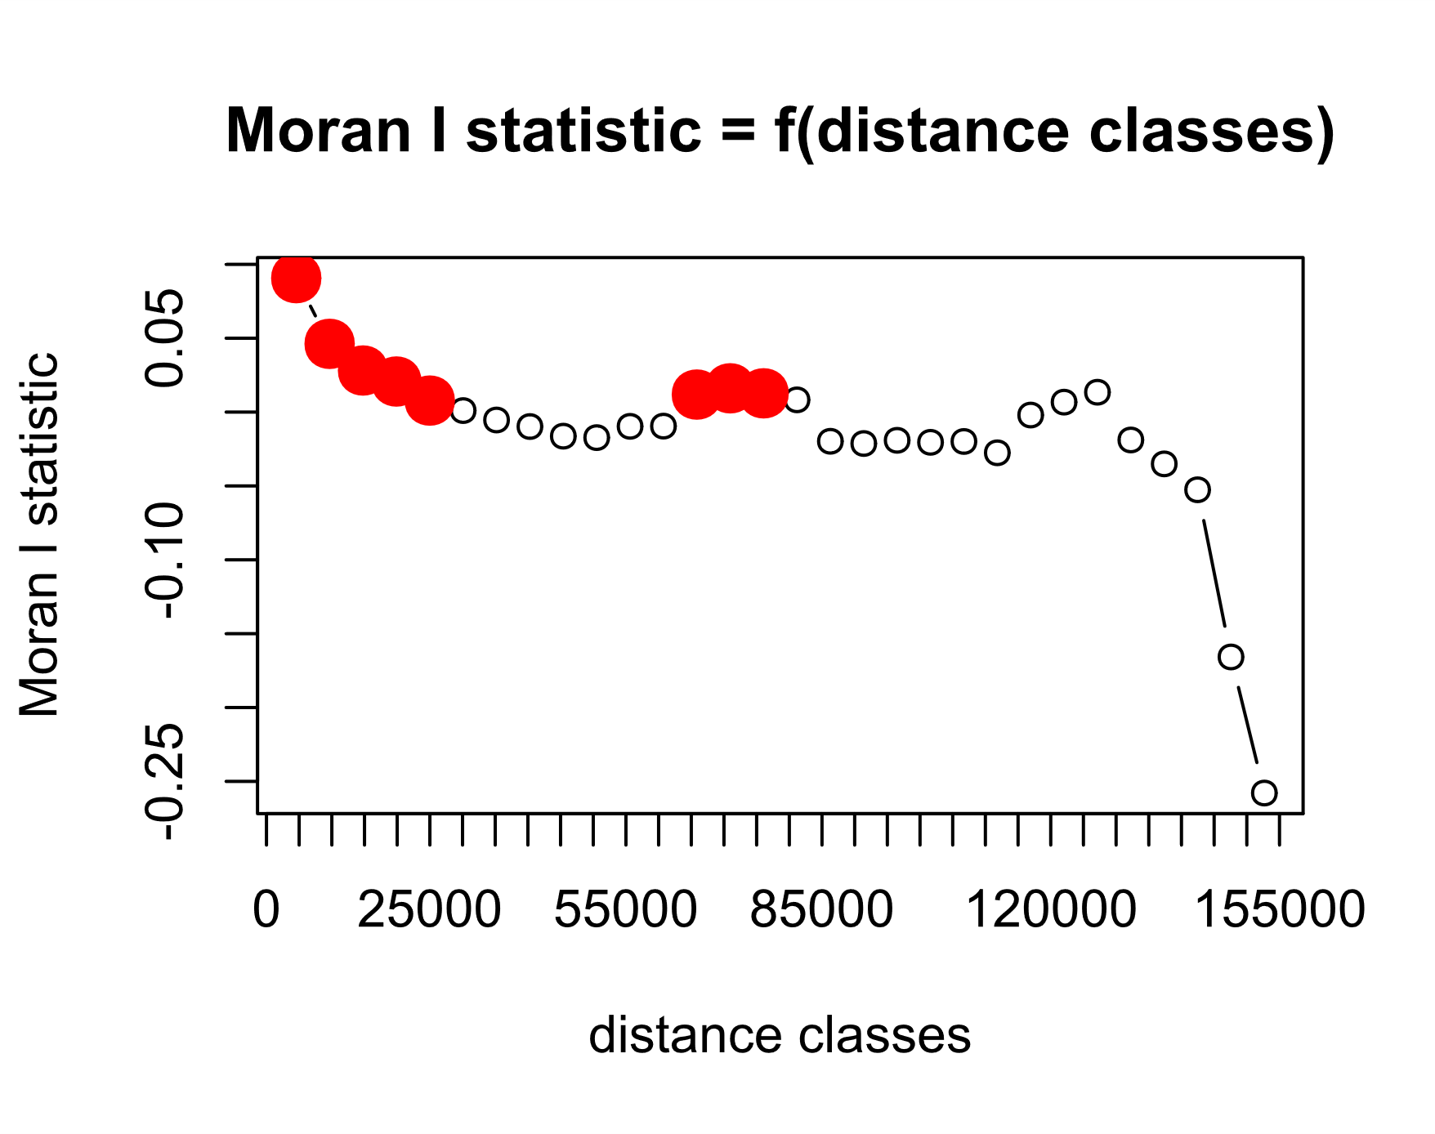

Figure S1: Moran’s I correlogram of regional logistic model of PUD presence. Values shown in red show significance a p<0.05 result and indicate spatial autocorrelation of the residuals. Computed using the pgirmess package in R studio.

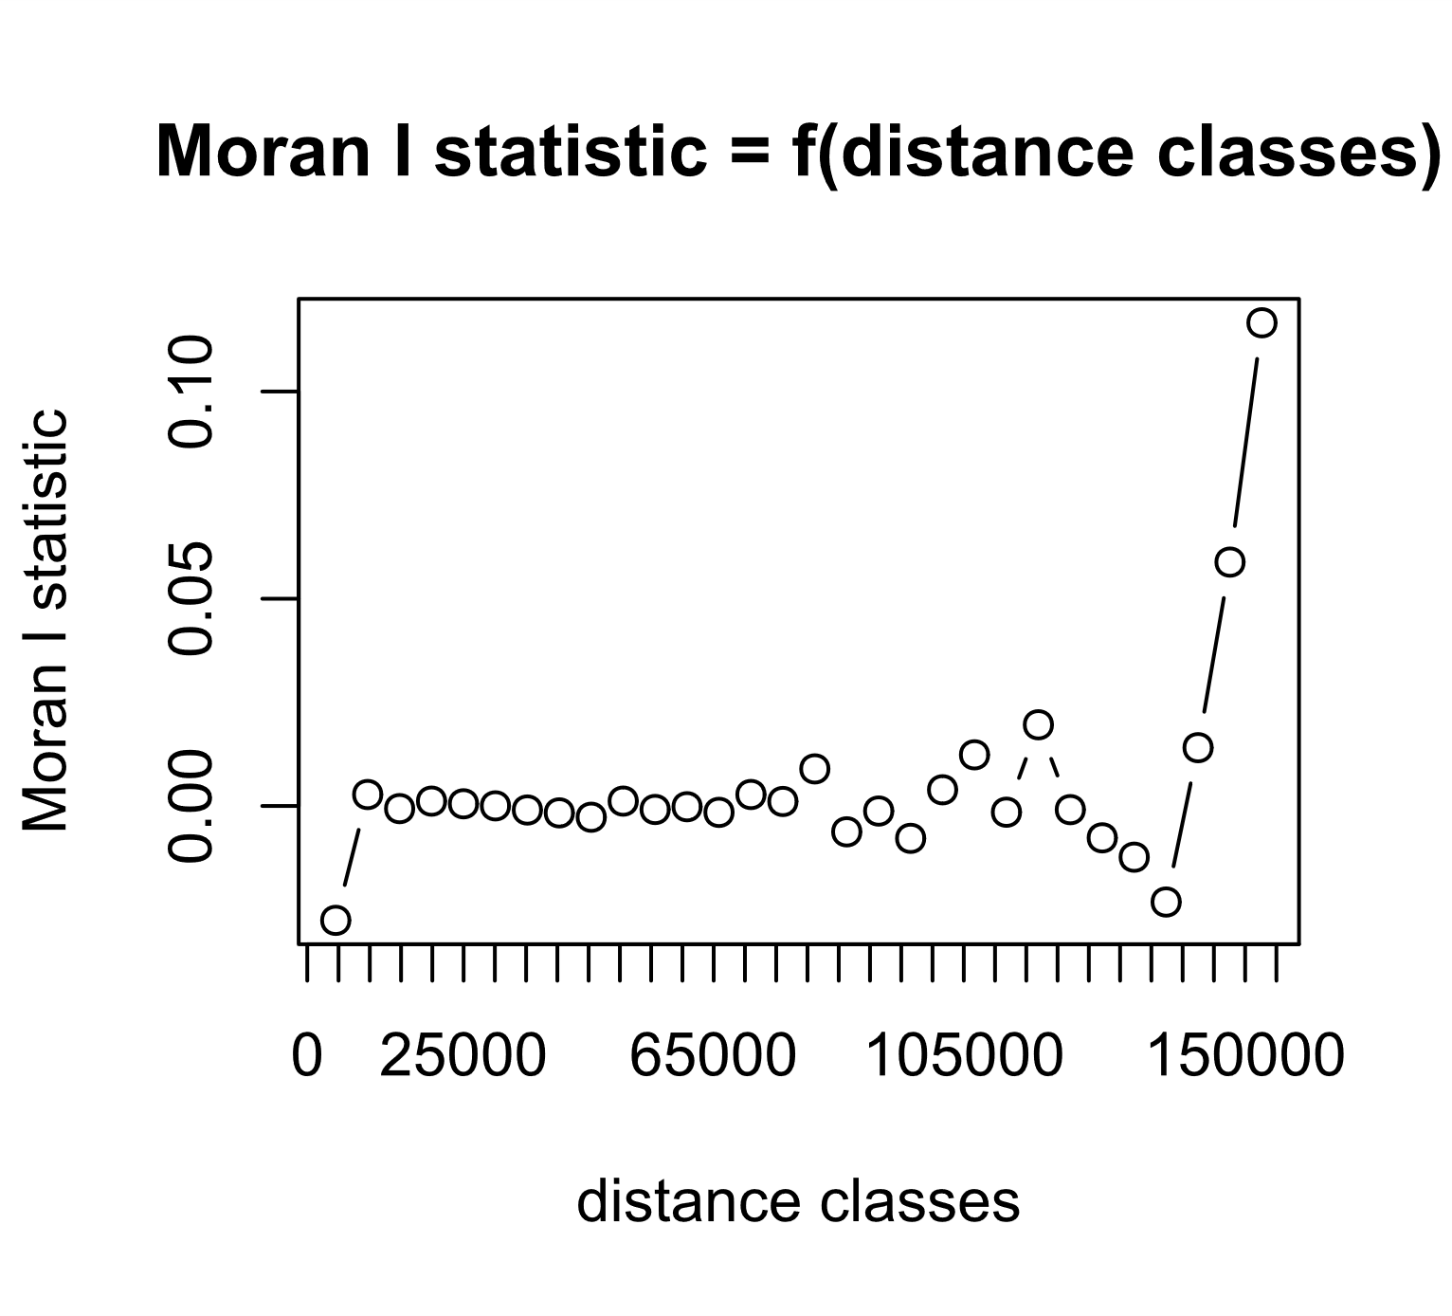

Figure S2: Moran’s I correlogram of regional SAM model of PUD counts. No evidence of spatial autocorrelation was detected. Computed using the pgirmess package in R studio.

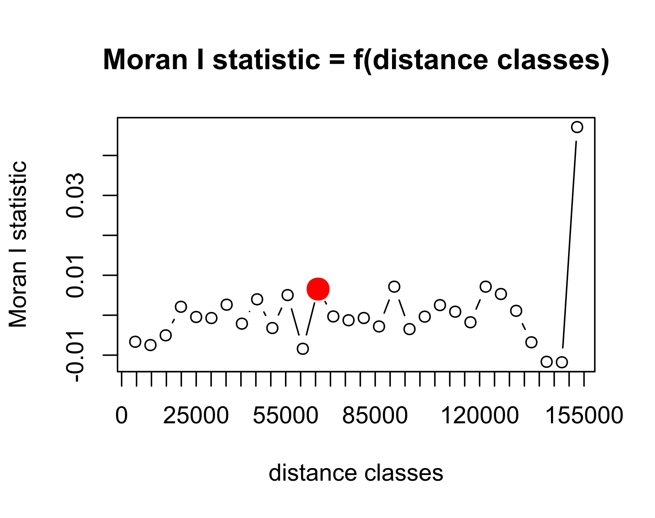

Figure S3: Moran’s I correlogram of logistic GWR model of PUD presence. Result does not support spatial autocorrelation of the residuals. Computed using the pgirmess package in R studio.