ANNEX

Tourism ecosystem service: survey to the visitors of the Venice lagoon

Survey methodology
The quantification of the tourism ecosystem service (ES), and particularly the mapping of its capacity, is based on the results of a survey addressed to the visitors of the Venice lagoon, conducted during the second semester of 2019. The survey has been distributed to people who have visited the lagoon and its islands outside the historical centre of Venice, including both private visits by means of public transport and guided boat tours. Those visiting only the city centre of Venice have not been included because they represent a different form of tourism (urban tourism) not necessarily related to the lagoon ecosystem. A specific questionnaire has been developed and administered to the visitors through both face-to-face interviews and self-administration. The latter has occurred in a variety of ways, which include mailing lists, posters and fliers displayed in tourist information offices and public places (hotels, restaurants, etc.), publication in websites and Facebook pages of tourism operators, and posts in social networks. In order to facilitate the distribution, the questionnaire has been prepared in four languages (Italian, English, German and French) and a webpage has been created where the questionnaires were made available to the public in the different languages.
The key aspect investigated is the relative importance attributed by the visitors to different factors of attractiveness. This is addressed in two questionnaire’s sections: (i) a first one asking for the relative importance attributed to the natural environment with respect to other general factors, namely, cultural heritage, food and wine, and boat excursion, and (ii) a second part asking for the relative importance of different factors connected with the state and functioning of the lagoon ecosystem, namely, the opportunity to observe typical elements of the lagoon landscape, the water quality, the presence of natural terrestrial habitats, the presence of birds and the presence of beaches. In both cases, the respondent could indicate the importance on a scale from not important to very important, and could specify other relevant factors of attractiveness not included in the list. Furthermore, the questionnaire asks for general information about the visiting trip (day-trip/overnight stay, place and duration of the stay, participation to naturalistic activities, areas of the lagoon visited) and general data of the respondent (age, sex, place of residence, education).
The responses concerning the factors of attractiveness were coded on a 0-1 scale, where 0=not important and 1=very important, and then averaged for each factor, obtaining a coefficient that expresses the relative importance of each factor of attractiveness.

Results of the survey
A total of 517 compiled questionnaires have been collected. The respondents are 61% female and 39% male, with the following age-class distribution: 2% between 0-17 years, 18% between 18-30 years, 21% between 31-45 years, 26% between 45-60 years, 25% over 60 years and 8% not specified. Most of the visitors have been reached through face-to-face interviews (66%), the remaining through fliers (12%), social media (11%), mailing list (4%), word-of-mouth (3%) and other channels (3%). Among those who specified their education level, the majority has completed upper secondary or higher education (36% and 49%, respectively), while the remaining 12% and 3% have completed lower secondary and primary education, respectively. Among those who have provided their place of residence, the majority are Italians (52%), of which the greatest share comes from the Veneto Region (72%), followed by Lombardia Region (11%) and Marche Region (6%). Among the foreigners, 70% of the respondents are coming from European countries. Concerning the characteristics of the visit, 60% of the respondents were staying overnight in the lagoon or in the surrounding areas, while 39% came for a day-trip (1% does not specify). 51% of the respondents have practiced naturalistic activities or ecotourism in the lagoon.
The first outcome that emerges from the analysis of the questionnaires is the relative importance attributed to the environment with respect to other general factors of attractiveness (Figure 1). Its importance is in fact approximately equal to that of cultural heritage. This underlines the key contribution of the lagoon ecosystem to the attractiveness of the area, confirming that visiting the lagoon outside Venice city is indeed an expression of a service coming from the ecosystem. Furthermore, among the factors of attractiveness freely expressed by the respondents, it notably emerges the landscape (6% of respondents), meaning the natural beauty and the peculiar atmosphere of lagoon villages, and the traditional, cultural and historical aspects (6% of respondents). Both these factors reflect the interpretation of the lagoon as a social-ecological system, in which the natural and social spheres are indivisible.
Figure 2 shows the importance attributed to the factors reflecting the state and functioning of the lagoon ecosystem. The opportunity to observe typical elements of the lagoon landscape has been given the greatest importance, followed by water quality, terrestrial habitats and birds. The presence of beach is given a lower importance, which is understandable, not being a typical component of the lagoon ecosystem.

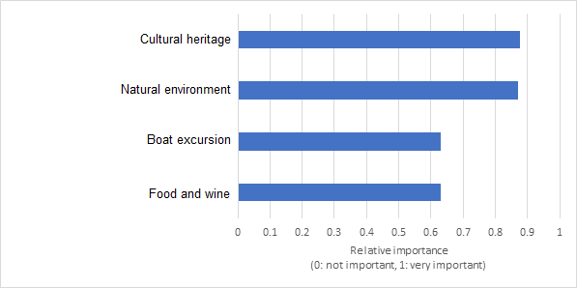
Figure 1. Relative importance attributed by visitors to general factors of attractiveness, expressed on a 0-1 scale where 0=not important, and 1=very important.
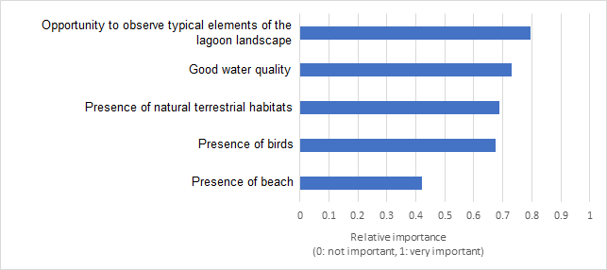
Figure 2. Relative importance attributed by visitors to factors of attractiveness related to the lagoon ecosystem, expressed on a 0-1 scale where 0=not important, and 1=very important.

Recreational navigation ecosystem service: survey to the pleasure-boat owners of the Venice lagoon

Survey methodology
The quantification of the recreational navigation ES is based on a survey addressed to the pleasure-boat owners of the Venice lagoon, conducted during the second semester of 2019. A specific questionnaire has been developed and administered to the local boaters through both face-to-face interviews and self-administration. The latter took place in a variety of ways, which include social networks (in particular Facebook groups to which several local boaters are inscribed), mailing lists, posters and fliers displayed in marinas and nautical items’ shops, and word-of-mouth. In order to facilitate the distribution, a webpage has been created where the questionnaires were made available to the public.
With respect to the capacity of this ES, the key aspects investigated are: (i) the relative importance attributed by the boaters to different activities that can be potentially practiced during boat trips (namely, visiting the islands of the lagoon, bathing and sunbathing, hunting, fishing, enjoying the lagoon landscape, and eat in restaurants reachable by boat or in the open air), and (ii) the level of appreciation of different zones of the lagoon (internal areas, intermediate “urbanized” areas and areas nearby the inlets). These areas are characterized, almost univocally, by different types of landscape (respectively, a typical lagoon landscape with salt marshes and shallow areas, a urbanized landscape and a landscape of transition between lagoon and sea), and by different levels of two factors very relevant for navigation, namely water traffic (low, intermediate and high, respectively) and navigation speed limits (low, moderate and high, respectively). In the questionnaire, these three areas have been described by explicitly mentioning these factors, with the aid of representative images. The respondent could indicate the importance on a scale from not important to very important, and could specify other relevant factors of attractiveness not included in the list. The responses concerning the relative importance of activities and appreciation of the areas were coded on a 0-1 scale, where 0=not important and 1=very important, and then averaged for each activity/area, obtaining a coefficient that expresses the relative importance of each.
With respect to the flow of this ES, the questionnaires were used to obtain information on the individual behaviour of pleasure-boat owners in the lagoon. In particular, we obtained the frequency of boat trips per year, along with the place where the boat is normally moored or stored and the areas of the lagoon visited.

Results of the survey
We collected 233 compiled questionnaires in total, of which 184 are motor boats owners and 49 sail boats owners. Most of the questionnaires have been collected through social networks. The sample is mainly composed by males (84%) with the following age class distribution: 10% aged 18-30 years, 33% aged 31-45 years, 31% aged 46-60 years, and 26% over 60 years old. Most of the respondents have completed upper secondary school (47%), 38% higher education, 14% lower secondary school and less than 1% elementary school. Given the greater share of motor pleasure-boats in the lagoon, we have considered the questionnaires from motor boat owners only. The importance attributed to the different activities and the appreciation of the different lagoon areas are reported in Figures 3 and 4, respectively. The observation of the lagoon landscape resulted be the activity with greatest importance, followed by bathing and visiting the lagoon islands. Regarding the different areas of the lagoon, the internal areas resulted to be the most appreciated, followed by the urbanized areas and the areas nearby the inlets. These two sets of results are consistent with each other: the mostly appreciated internal areas are where the most important activity, the observation of the typical lagoon landscape, can be practiced (result that confirms the importance of the lagoon ecosystem for this recreational activity). Similarly, the intermediate appreciation of urbanized areas is in good agreement with the intermediate importance attributed to the two main activities that can be practiced in these areas, namely visiting the islands and eating in restaurants. Finally, bathing and fishing (second and fifth in order of importance) are generally practiced nearby the inlets, area which received the lowest appreciation. The discrepancy between the relatively high importance of bathing and the low appreciation of the inlets areas can be explained by the high water traffic that characterize these areas during the summer, which may diminish their attractiveness. Considering the average individual behaviour of pleasure boaters, it emerges an average frequency of about 37 boat trips/person/year, mainly concentrated during the summer period.
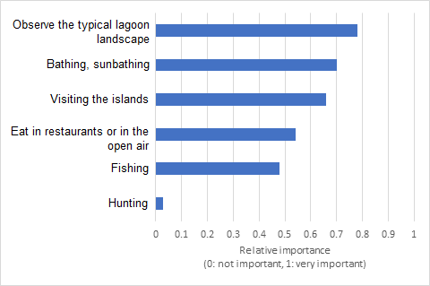
Figure 3. Relative importance attributed by pleasure-boat owners to different activites, expressed on a 0-1 scale where 0=not important, and 1=very important.

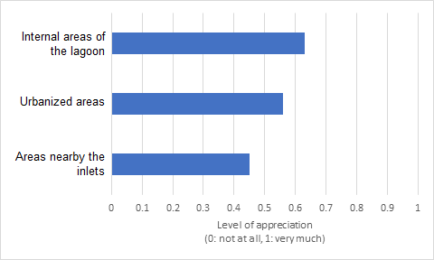
Figure 4. Level of appreciation of different areas of the lagoon, expressed on a 0-1 scale where 0=not at all, and 1=very much.

Recreational fishing ES: survey to recreational fishermen of the Venice lagoon

Survey methodology
The quantification of the recreational fishing ES makes use of the results of a survey aimed at characterizing the activity of recreational fishermen in the Venice lagoon, conducted during the second semester 2019. A questionnaire has been developed and administered to the fishermen through both face-to-face interviews and self-administration. Fishermen have been contacted in a variety of ways, which include social networks (in particular Facebook groups to which several recreational fishermen of the Venice lagoon are inscribed), recreational fishing associations (part of the Italian Federation of Sport Fishing and Underwater Activities, FIPSAS), mailing lists, and through bait shops and word-of-mouth. In order to facilitate the distribution, a webpage has been created where the questionnaires were made available to the public.
The main questions regard the fishing techniques, preferences in terms of target species, fishing areas, catches and fishing effort (in terms of number of trips per week in the different seasons). Based on the data collected through the survey, we estimated the average fishing effort per fisherman (n. of fishing trips/fisherman/year), the catches per unit of effort (CPUE, g/fisherman/trip) for the main target species, and the fraction of fishermen that target a certain species.

Results of the survey
A total of 127 compiled questionnaires were collected, mainly obtained through social media (62%), followed by word-of-mouth (13%), recreational fishing associations (12%), fliers (5%), mailing lists (5%) and direct interviews (3%). The whole sample is composed of males, with the following age-class distribution: 2% under 18 years old, 15% aged between 18-30 years, 38% aged between 31-45 years, 31% aged between 46-60 and 14% over 60 years old. Most of the respondents have completed upper secondary school (52%), 27% lower secondary school, 18% higher education, 1% elementary school (2% did not specify).
The average individual behaviour that resulted from the survey has the following characteristics: an average fishing effort of about 47 fishing trips/fisherman/year, mainly concentrated in summer and autumn, with a average CPUE of 4.55 kg/fisherman/trip. The main target species are seabream, seabass and cuttlefish, while the favourite areas of fishing are the inlets (43% of the yearly trips) and the channels nearby (27% of the fishing trips). About 30% of the fishing trips occurs in the facing sea areas.

