Supplementary material 6: Demand index at Regional level, inhabitants within 4 km (A) and 300 m (B) from an area with high level of opportunities for nature-based recreation.
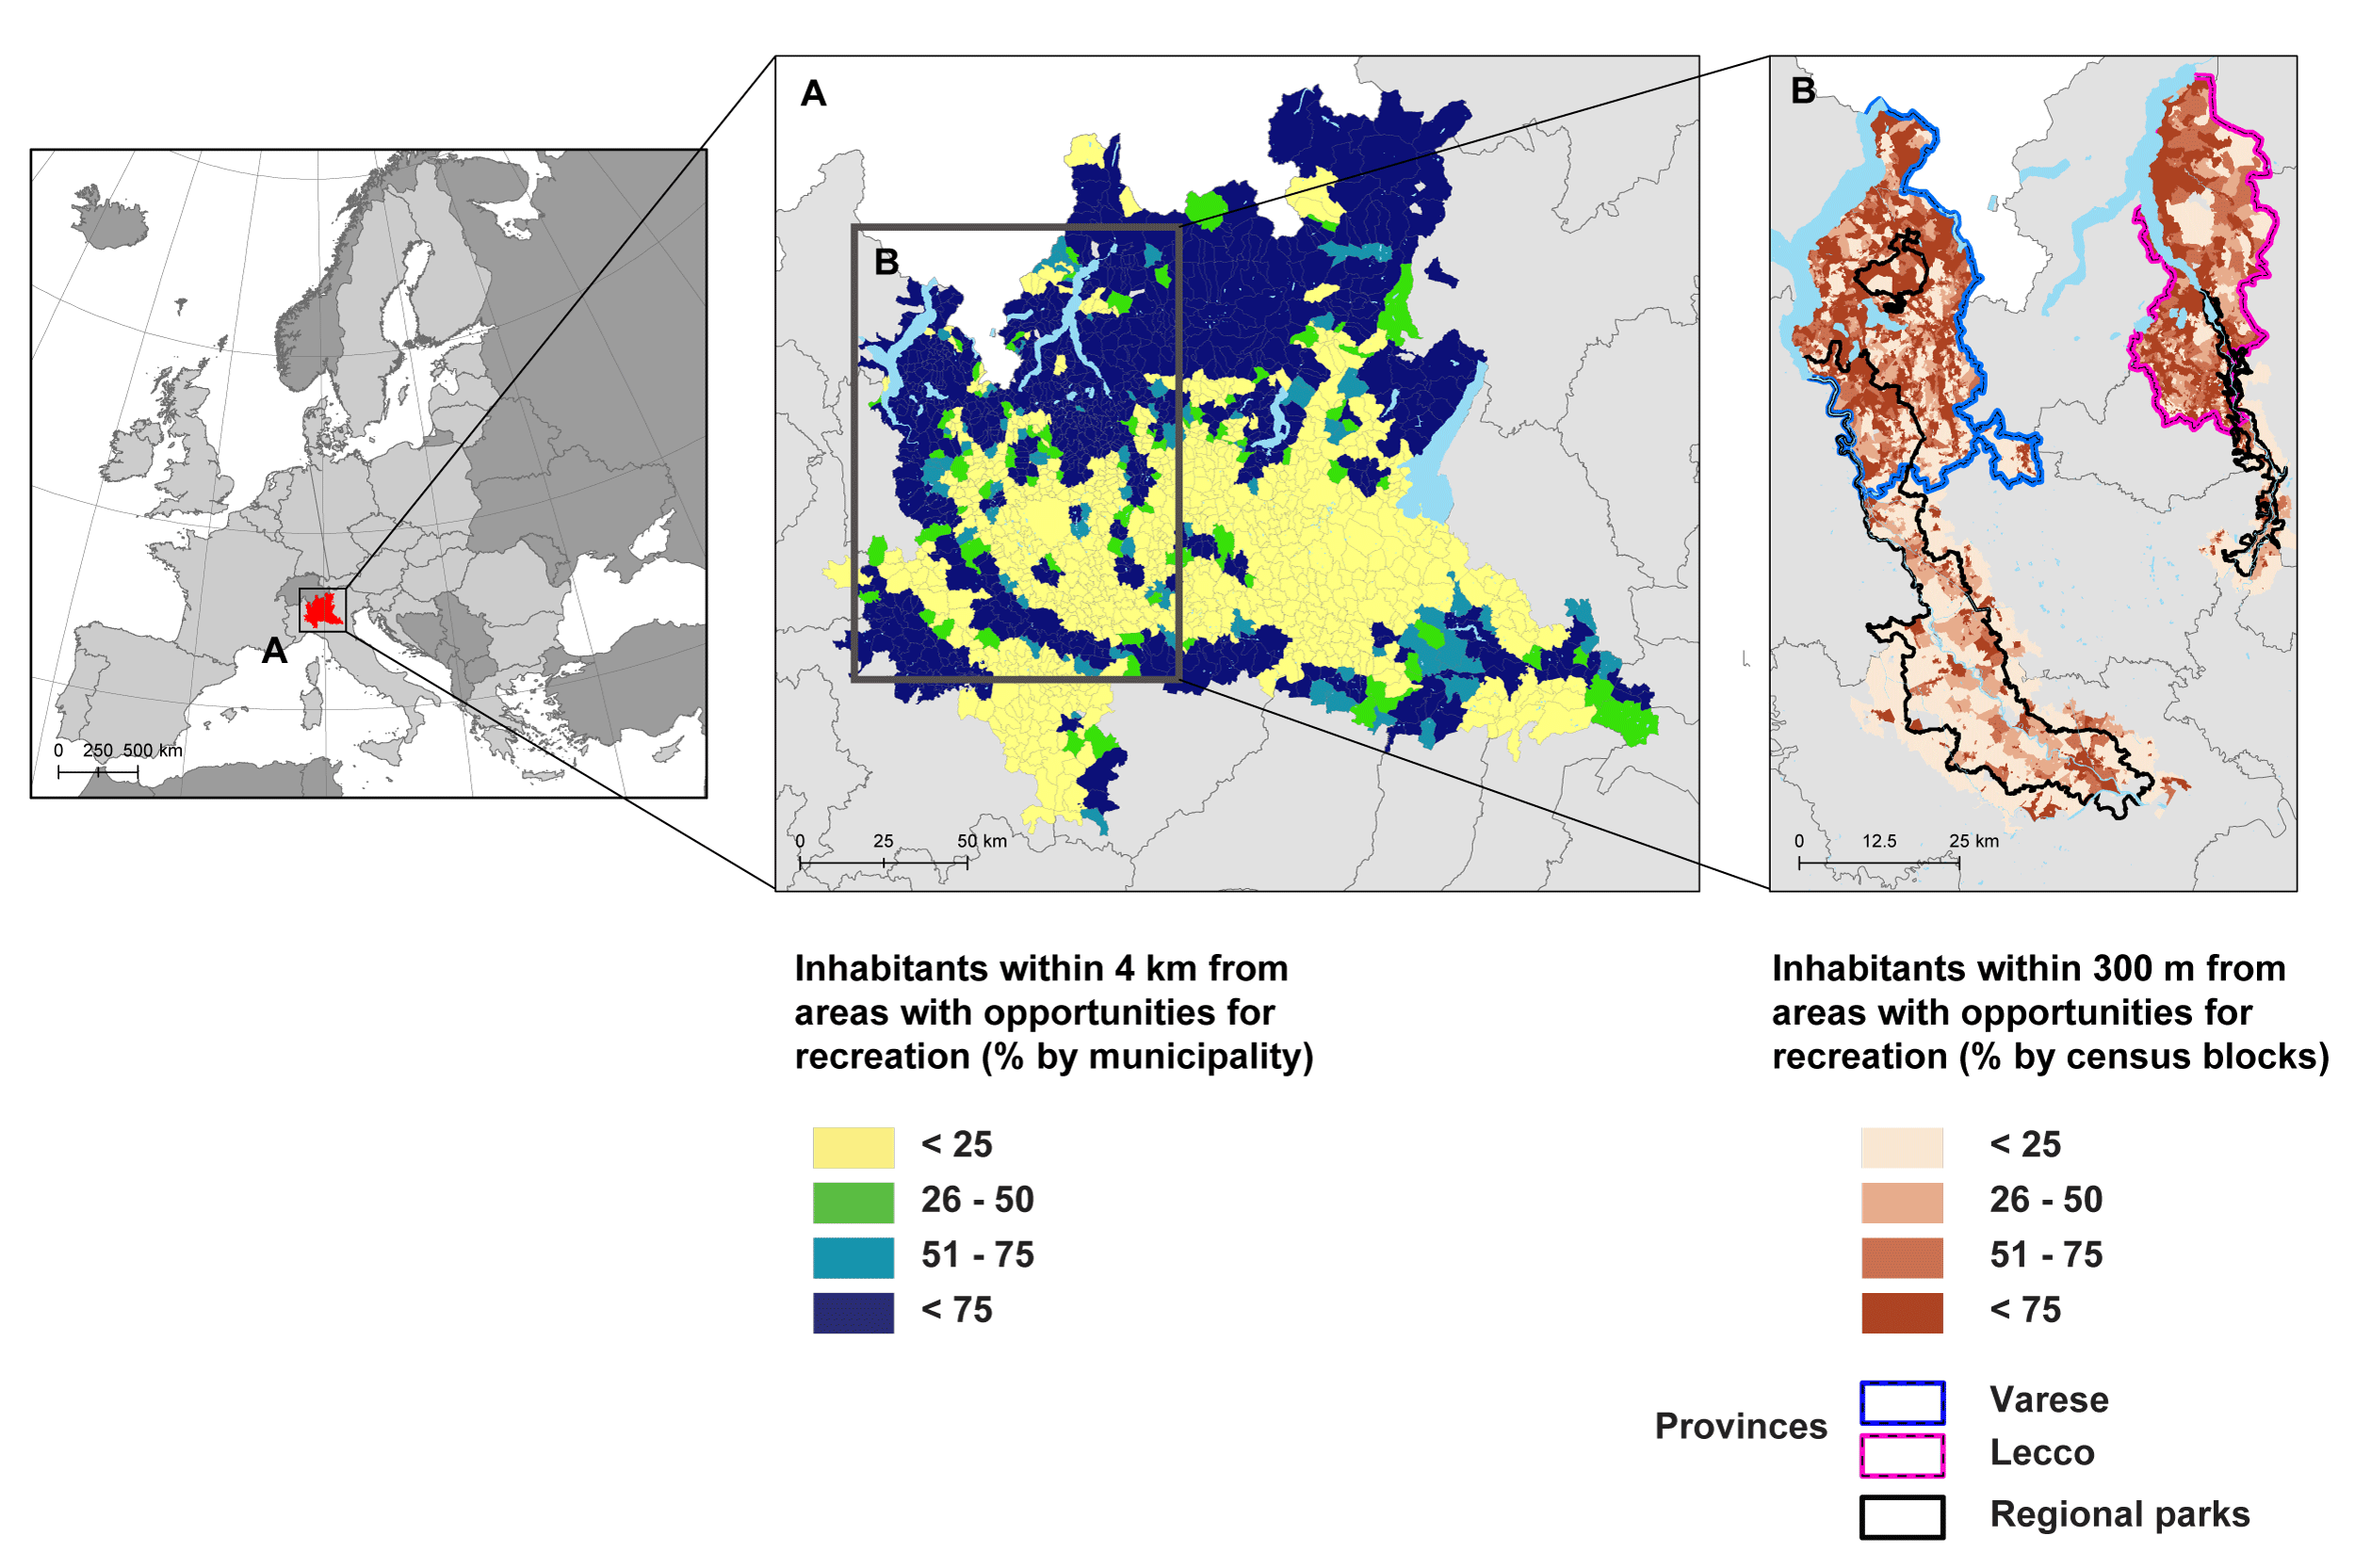
The figure shows the share of the local population that lives within 4 km of a location that provides high values lives of opportunities for recreation. The spatial resolution of population data in map A was 1 km, it is relative to the European context and was aggregated at municipality level (Vallecillo 2019). Map B shows the share of the population that lives within 300 m to a site that provides opportunities for outdoor recreation. In this case, population data was very precise, geolocated at building level and data were aggregated per census blocks (see Suppl. material 4).

