Supplementary material
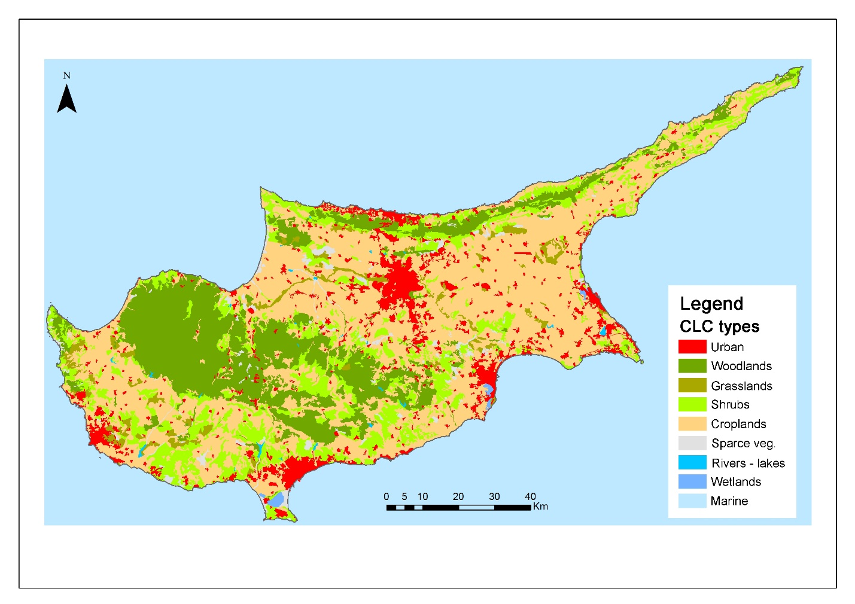
Figure S1. Map of Land use in Cyprus (based on Corine 2012).
The categories presented in the legend represent the following Level 3 categories of the CLC2012. Urban: 111, 112, 121-4, 131-3, 141-2; Woodlands: 311-3, 324; Grasslands: 231 321; Shrubs: 323; Croplands: 211, 212, 221-3, 241-3; Sparse veg.: 331-4; Rivers-lakes: 511-2; Wetlands: 411, 421; Marine: 523

Table S1: Evaluation of the appropriateness of the Maes et al. (2014) indicators (agroecosystems) for their use in MAES in Cyprus (in blue are the indicators introduced for Cyprus; not present in Maes et al.)
Indicator suitability | Green | Provisioning  1. Livestock data (LU/ha, Ton meat/yr/region)  2. Grazing density (number of animals per ha)  3. Yields of fiber crops (ton/ha; ton dry matter/ha; MJ/ha)  4. Fiber crop area (ha)  5. Number of beehives  Regulating  -  Cultural  6. Number of visitors in agricultural/rural areas | Provisioning  1. Yields of food and feed crops (ton/ha; ton dry matter/ha; MJ/ha)  2. Energy from manure treatment systems (kWh)  3. Number of hunter licenses by Game and Fauna Service (GFS)  Regulating  -  Cultural  4. Number of bird-watchers  5. Number of scientific studies related to agroecosystems | Provisioning  1. Agricultural area (ha)  2. Hunting areas and seasons  3. Areas important for groundwater abstraction in agroecosystems  4. Areas with access to treated municipal wastewater for irrigation  5. Groundwater bodies location in the island  6. Yields of feed or food crops (ton/ha; ton dry matter/ha; MJ/ha)  7. Area of energy crops (ha)  8. Biofuel, biodiesel, bioethanol (kToe)  9. Agricultural areas equipped with irrigation facilities  Regulating  10. High Nature Value Farmland (HNVF)  11. Number of floods/year that cause problems in agricultural areas.  12. Traditional plantations/orchards area (ha)  13. Area cultivated with legumes  14. Humidity Index  15. Land Use Change  Cultural  16. Density and number of bicycle routes and trails into agricultural and forest land.  17. Number of environmental info centers into agricultural areas.  18. Number of agricultural/ traditional festivals  19. Religious monuments, pilgrim paths in agro-ecosystems  20. Number of traditional, PDO (Protected Designation of Origin) and PGI (Protected Geographical Indication) products in an area  21. Number of nature/agricultural landscape photos uploaded on web portals  22. Number and capacity of agritourist hotels/ motels in an area  23. Landscape degree of hemeroby  24. Agricultural landscape structure.  25. Symbolic species  26. Percentage of agricultural land into protected areas
 | Orange | Provisioning  1. Use of animal feed (Tons/year)  2. Honey production and consumption per year  3. Yields of crops used for medicinal and cosmetic purposes (ton/ha; ton dry matter/ha; MJ/ha)  Regulating  4. Retention capacity of water in agricultural soils  Cultural  - | Provisioning  1. Manure production (ton/year )  Regulating  2. Habitat suitable for bees (distribution and area) P surplus in agricultural land (kg P/ha/year ).  3. N surplus in agricultural land (kg N/ha/year ).  4. Areal coverage of vegetation features supporting pollination (hedgerows, flower strips, High Nature Value Farmland etc.)  5. Chemical status of surface water in agricultural areas  6. Ecological status of surface water in agricultural areas  7. Groundwater quality/ salinization  8. Groundwater recharge rate  9. Carbon sequestered by permanent crops  10. CO₂ emissions from agriculture and animal husbandry (ktonnes CO₂ equivalents/year) – Carbon Footprint.  Cultural  11. Expenditures related to hunting  12. Number of farms offering training/ education (didactic farms) | Provisioning  - Wild game species and population reared and released each year  - Groundwater bodies with salinization problems  - Water use in agriculture.  - Recycled (treated) water use in agriculture (m3/year).  - Surface water use for irrigation (m3/year).  - Percentage of agricultural and pasture land into flood plains  Regulating  - Soil organic matter content  - pH of the soil surface  - Cation Exchange Capacity in soils  Cultural  - Remarkable trees  - Symbolic species
 | Red | Provisioning  1. Habitat distribution for wild mushroom species  2. Production of mushrooms  3. Estimation of the number of game species in each hunting area  4. Methane production from manure treatment (Ton/year)  Regulating  5. Hedgerows length in agricultural land  6. Soil cover percentage in agricultural land  7. Hedgerow density  8. Pollination potential  9. Pollinators distribution  10. Pollinator species abundance  11. N balance in agricultural and pasture land  12. Number of visitors/ tourists in agricultural land  Cultural  13. Public perception for the value of the agricultural landscape  14. Willingness to pay for landscape measures in cropland or grassland areas | Provisioning  -  Regulating  1. Pollutants concentration in agricultural soils.  2. Pesticides concentration in ground and surface water.  3. Nitrate concentration in surface and ground water  4. Soil erosion risk  Cultural  - | Provisioning  1. Hunting activity in each area.  2. Game species population size.  3. Groundwater pumped per area and year (m3/year).  Regulating  4. Nutrients concentration in agricultural land (C, N, P, K, Ca, Mg, S).  Cultural  -
 |  | Red | Orange | Green

 | Very high |  |  | Moderate |  |  | Very low
 | High |  |  | Low

Data appropriateness for the determination of indicators for MAES in agricultural land and pastureland.

Indicator appropriateness | Green | Provisioning  1. Number of beehives  2. Distribution of foraging areas in forest; estimate of grassland/shrubland (NPP)  Regulating  3. Surface of healthy Forests (quality parameter of forest health)  Cultural  - | Provisioning  1. Amount of meat (hunting)  2. Value of game  3. Hunting records (killed animals)  4. Number of hunting licenses  Regulating  -  Cultural  5. Number of bird-watchers  6. Number of scientific research documents for forests | Provisioning  1. Hunting areas and seasons  2. Important areas for groundwater abstraction  3. Forest biomass stock  4. Forest biomass increment  5. Forest for timber, pulp wood, etc. production  6. Commercial forest tree volume & harvesting rates  7. Trees (presence): pines for resins  8. Tree species (timber trees)  9. Wood consumption (industrial roundwood, fuelwood)  Regulating  10. C storage in forest  11. C sequestration by forest (NPP; NEP)  12. Forest soil condition: chemical soil properties  13. Areas where aquifers are located  14. Forest area (ha)  15. Area of peri-urban forests  16. Forest species distribution  17. Investments in forests maintenance/ management  18. Protected Areas for nursery populations  19. Forest area designated for habitat-landscape protection: Natura2000, etc  Cultural  20. Density and number of bicycle routes and trails into agricultural and forest land  21. Number of environmental information/education centers  22. Number and density of natural trails or nature study trails  23. Number of visitors  24. Number of nature/agricultural landscape photos uploaded on web portals  25. Distribution of sites of emblematic plants/forest/species  26. Religious monuments  27. Number and capacity of hotels/motels in forest areas  28. Percentage of agricultural land into forest area
 | Orange | Provisioning  1. Habitat and plants distribution for wild bee species  2. Honey production (modelling)  3. Distribution of plants used in medicine and cosmetics industry  4. Host-species (trees) abundance  5. Restoration costs  6. Amount of dead wood  Regulating  7. Important areas for water infiltration and headwater surroundings covered by forest  8. Drought and water scarcity  9. Special protection areas for preventing mass flows linked to the River Basin Management Plans  Cultural  - | Provisioning  1. Number of goats/sheep in forest land (e.g. Akamas peninsula)  2. Animal production (milk, meat, cheese)  3. Water supply and discharge (hydrological modelling)  Regulating  4. Albedo maps  5. Leaf Area Index  6. Erosion protection (modelling)  7. Area of forest designated to the prevention of soil erosion  8. Area eroded by wind and water  9. Forest cover in high slope areas (GIS analysis)  10. Forest area designated for attenuation of mass flows  11. Erosion risk mitigation  12. Flood risk mitigation  Cultural  13. Hunting expenditures | Provisioning  1. Number of pray reared and released  2. Wood fuel stock (fraction of forest biomass stock)  3. Wood fuel production (fraction of forest biomass increment)  4. Distribution of trees for wood production  5. Fuel wood consumption  6. Natural mineral water production  7. Areas managed for gene conservation  Regulating  8. Sulphur (S) and Nitrogen (N) retention and removal  9. Urban and sub-urban forest area  Cultural  10. Emblematic species presence  11. Important Bird and Biodiversity Areas (IBAs)  12. Area available/accessible for recreation  13. Condition of forest-associated priority species on habitat and birds directives  14. Distribution of sites with forest designated as having cultural values  15. Number of sites with recognized cultural & spiritual value  16. Number of Ecotourism operators into forest land
 | Red | Provisioning  1. Wild berries, fruits and mushroom harvest  2. Distribution of wild berries (modelling)  3. Production and consumption of mushrooms  4. Population status for game species  5. Distribution of plants species with biochemical/pharmaceutical uses  Regulating  6. Sediments removed from dams, lakes, rivers  7. Pollination potential (maps)  8. Abundance of pollinators (maps)  Cultural  - | Provisioning  -  Regulating  1. Erosion risk mitigation  Cultural  - | Provisioning  1. Area of forests accessible for hunting  2. Surface water provisioning in rivers located in forest areas  3. Rivers discharge  4. Water in dams/ reservoirs  5. Water consumption per capita  Regulating  6. Forest area (designated to preserve water resources)  Cultural  -
 |  | Red | Orange | Green
Table S2: Evaluation of the appropriateness of the Maes et al. (2014) indicators (forests land) for their use in MAES in Cyprus (in blue are the indicators introduced for Cyprus; not present in Maes et al.)

 | Very high |  |  | Moderate |  |  | Very low
 | High |  |  | Low

Data appropriateness for the determination of indicators for MAES in forest land.

Table S3: Evaluation of the appropriateness of the Maes et al. (2014) indicators (freshwater) for their use in MAES in Cyprus (in blue are the indicators introduced for Cyprus; not present in Maes et al.)
Indicator suitability | Green | Provisioning  1. Wild plants used in gastronomy, cosmetic, pharmaceutical uses (data on industries collecting the plants)  Regulating  -  Cultural  2. Number of visitors/ fishing licenses  3. Bathing areas and number beaches (lakes and streams) | Provisioning  1.Number of licensed fisherman (anglers, professional and amateur fishermen) per fishing category (fishing net, fishing rod, fishing weir/reservoirs)  2. Estimated number of fishing fleet for professional fishermen  3. Wood produced (tons or m3) by riparian forest  4. Surface of exploited (fiber harvesting and timber) riparian forest and reeds  5. Products (number and type) from reeds (eg Fasouri wetland)  6. Firewood produced by riparian forests  7. Number of fishing licenses  Regulating  -  Cultural  8. Tourism revenue | Provisioning  1.Number and area of the dams that fishing is allowed  2. Number and production (per species) of fish farms  3. Freshwater aquaculture production (e.g. trout production)  4. Water consumption for drinking  5. Number and capacity of dams  6. Number of boreholes in watersheds  7. Volume of water bodies  8. Stream water discharge  9. Extent of permanent flow section per stream  Regulating  10. Nitrate Vulnerable Zones (NVZs)  11. Area of riparian forests  12. Number and efficiency of wastewater treatment plants  13. Volume of treated wastewater (tons/year)  14. Area of wetlands  15. Floodplains areas (and record of annual floods)  16. Floodplains area  17. Area of wetlands located in flood risk zones  18. Ecological status  19. Morphological status  20. Number of introduced vertebrates in rivers and riparian areas  21. Chemical status  22. Surface of flood-prone areas  23. Percentage of wetlands covered by Natura 2000 areas  Cultural  24. National Parks and Natura 2000 sites  25. Waterfalls  26. Fishing reserves  27. Classified sites (world heritage, label European tourism)  28. Number of Environmental Centers in wetlands areas  29. Natural heritage and cultural sites  30. Number of visitors (surface or number of wetlands located next to a bike path)  31. Number or area of wetlands near nature study trails or natural trails for walking  32. Number or area of wetlands that have birdwatching or facilities for educating/ informing citizens.  33. Contrasting landscapes (lakes close to mountains)  34. Sacred/religious sites (catastrophic events, religious places)  35. Proximity to urban areas of scenic rivers or lakes
 | Orange | Provisioning  -  Regulating  1.Nutrient retention  2. Sediment retention  3. Wetland value to conserve pollinator populations  4. Number of introduced aquatic invertabrates  Cultural  5. Number of visitors (national parks including rivers, lakes and wetlands) | Provisioning  1. Fish production (tons/year) per category  Regulating  2. Ground water quality (salination)  3. Holding capacity; flood risk maps  4. Conservation of river and lake banks and wetlands  5. Conservation status of wetlands  6. Riparian zone width  7. Biodiversity value (species diversity or abundance, endemics or red list species and spawning location)  8. Alien species (introduced riparian and aquatic plants)  Cultural  9. Tourism revenue  10. Number of visitors  11. Fish abundance  12. Fish monetary value from angling  13. Number of scientific projects, articles, studies  14. Number of unions, foundations and NGOs dealing with animals, plants, nature and the environment | Provisioning  1.Surface water availability  2. Surface water abstraction  3. Water use per sector  Regulating  5. Minimum ecological flow  6. Water flow downstream of dams  7. Indicators on water quality (microbiological data for bathing waters, BOD5 nitrate conc, phosphate concentration, oxygen conditions, saprobiological status)  8. Nutrient load  9. Trophic status  10. Ecological status of riparian zone  11 Volume and hydrological flow  12. Water holding capacity of soils  Cultural  14. Known bird watching sites  15. Quality of fresh waters for fishing  16. Monitoring sites (by scientists)  17. Number of annual cultural activities  18. National species or habitat types
 | Red | Provisioning  1.Status of fish population (Species composition, 2. Age Structure, Biomass kg/ha)  Regulating  3. Carbon storage per unit of area  4. Potential mineralization or decomposition  5. Denitrification  6. Nitrogen fixation  7. Dissolved oxygen  Cultural  8. Social perception of wetlands | Provisioning  -  Regulating  -  Cultural  - | Provisioning  -  Regulating  1.Hydromorphic soils  2. Fluvisols surface  Cultural  -
 |  | Red | Orange | Green

 | Very high |  |  | Moderate |  |  | Very low
 | High |  |  | Low

Data appropriateness for the determination of indicators for MAES in freshwater.

