Regional classifications of Member States

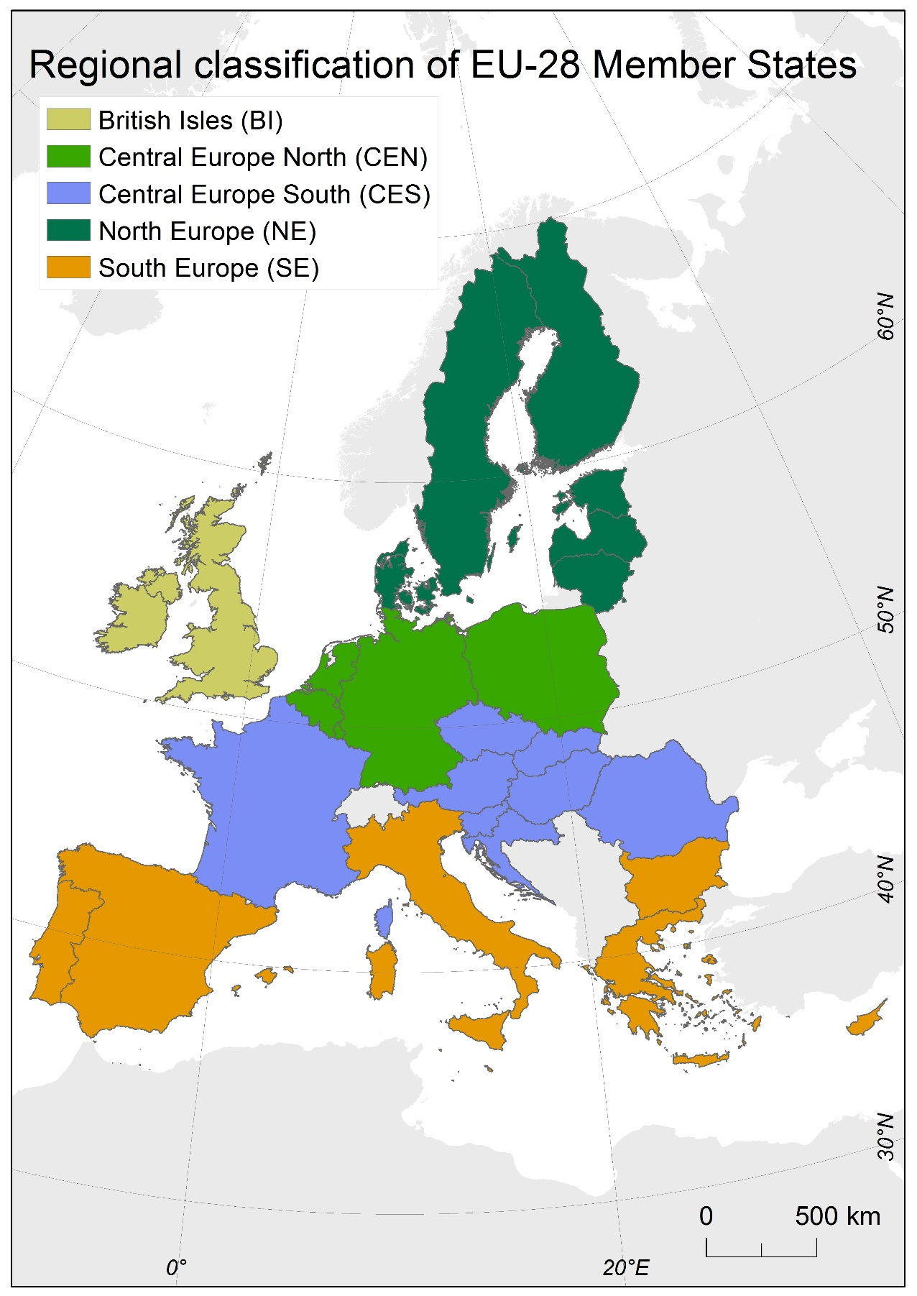
Figure S. 2: Regional classification of the 28 EU Member States, updated from Ciscar et al. (2011).

Reference
Ciscar Martinez JC, Iglesias A, Feyen L, Szabó L, Van Regemorter D, Amelung B, Nicholls R, Watkiss P, Christensen OB, Dankers R, Garrote L, Goodess CM, Hunt A, Moreno A, Richards J, Soria A (2011) Physical and economic consequences of climate change in Europe. Proceedings of the National Academy of Sciences of the United States of America 108 (7): 2678‑2683. URL: http://www.scopus.com/inward/record.url?eid=2-s2.0-79952599340&partnerID=40&md5=647d8e90e3e4421d0fd09497096e84ad

