Bayesian Network
Figure A1 shows a simple Bayesian Network, illustrating two reasons causing a tree to lose its leaves, apart from its normal life cycle: drought and disease. The variables of the BN are called nodes and may be connected to one other by unidirectional links. A node that has one or more links going out of it is called ‘parent’, whilst a node that receives one or more links form other variables is called ‘child’. Thus a node can be both parent and child. Nodes are characterized by two main features:
- States, which must be at least two and describe the values that the variable can take; they can be of any data type (e.g. numbers, intervals, qualitative …) but cannot be overlapping;
- Conditional Probability Tables (CPT), which describe for each node the probability associated to a particular state, given the state of its parents’ node(s).
Conditional Probability Tables can be filled in using a range of techniques, from available evidence to expert opinion, and may include cases of equal probabilities across states (i.e. equal chances).
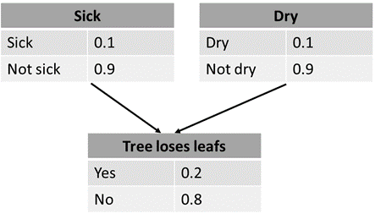
Figure A. 1: Example of Bayesian Network describing the possible causes of a loss of leaves (modified from www.hugin.com)

